Exercise 4: React Component Lifecycle Methods
Aim
To study React Component Lifecycle Methods and implement componentDidMount() and componentDidCatch() lifecycle hooks.

Theory Questions and Answers
1. Explain the Need and Benefits of Component Lifecycle
A React component passes through different phases during its existence, known as the Component Lifecycle.
These phases help developers execute code at specific points such as when a component is created, updated, or removed.
Benefits
- Perform API calls after component creation.
- Update UI dynamically.
- Handle errors efficiently.
- Improve application performance.
- Manage resources and memory.

2. Various Lifecycle Hook Methods
Mounting Phase
Methods called when a component is created and inserted into the DOM.
- constructor()
- static getDerivedStateFromProps()
- render()
- componentDidMount()

Updating Phase
Methods called when state or props change.
- static getDerivedStateFromProps()
- shouldComponentUpdate()
- render()
- getSnapshotBeforeUpdate()
- componentDidUpdate()
Unmounting Phase
Called when a component is removed from the DOM.
- componentWillUnmount()
Error Handling Phase
Methods used to handle errors.
- static getDerivedStateFromError()
- componentDidCatch()

3. Sequence of Steps in Rendering a Component
Mounting Sequence
Constructor()
↓
getDerivedStateFromProps()
↓
render()
↓
componentDidMount()
Updating Sequence
getDerivedStateFromProps()
↓
shouldComponentUpdate()
↓
render()
↓
getSnapshotBeforeUpdate()
↓
componentDidUpdate()
Unmounting Sequence
componentWillUnmount()

4. componentDidMount()
componentDidMount() executes immediately after the component is rendered for the first time.
Uses
- API calls
- Database access
- Fetching data
- Initializing timers
Syntax
componentDidMount() {
console.log("Component Mounted");
}

5. componentDidCatch()
componentDidCatch() is an Error Boundary lifecycle method used to catch JavaScript errors occurring in child components.
Uses
- Prevent application crashes
- Display fallback UI
- Log errors
Syntax
componentDidCatch(error, info) {
console.log(error);
console.log(info);
}

Procedure:
- Create a new react application using create-react-app tool with the name as “blogapp”
- Open the application using VS Code
- Create a new file named as Post.js in src folder with following properties
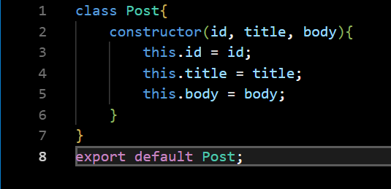
- Create a new class based component named as Posts inside Posts.js file
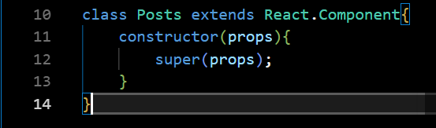
- Initialize the component with a list of Post in state of the component using the constructor
- Create a new method in component with the name as loadPosts() which will be responsible for using Fetch API and assign it to the component state created earlier. To get the posts use the url (https://jsonplaceholder.typicode.com/posts)

- Implement the componentDidMount() hook to make calls to loadPosts() which will fetch the posts

- Implement the render() which will display the title and post of posts in html page using heading and paragraphs respectively.

- Define a componentDidCatch() method which will be responsible for displaying any error happing in the component as alert messages.

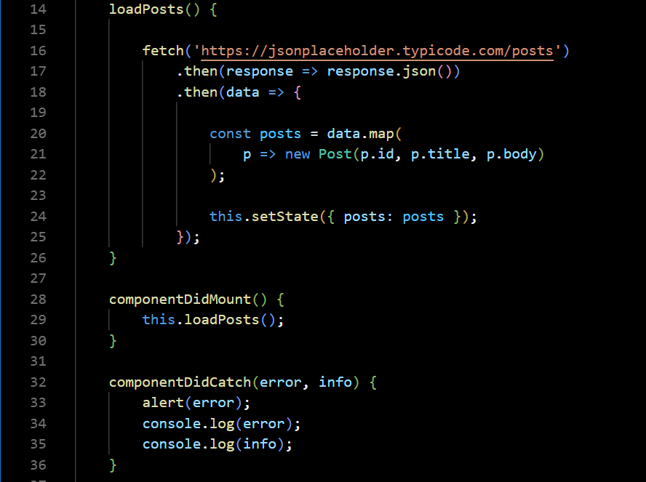
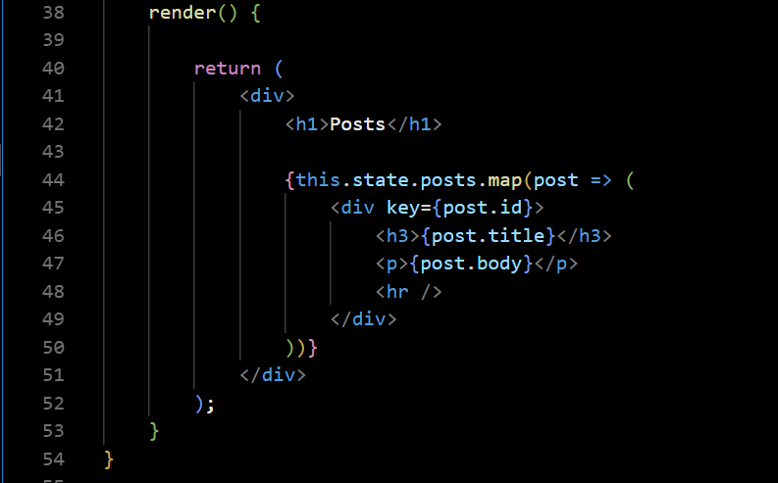

- Add the Posts component to App component.
- Build and run the application using npm start command.

Output
The application successfully fetched posts from the JSONPlaceholder API using the componentDidMount() lifecycle method and displayed the title and body of each post on the webpage.
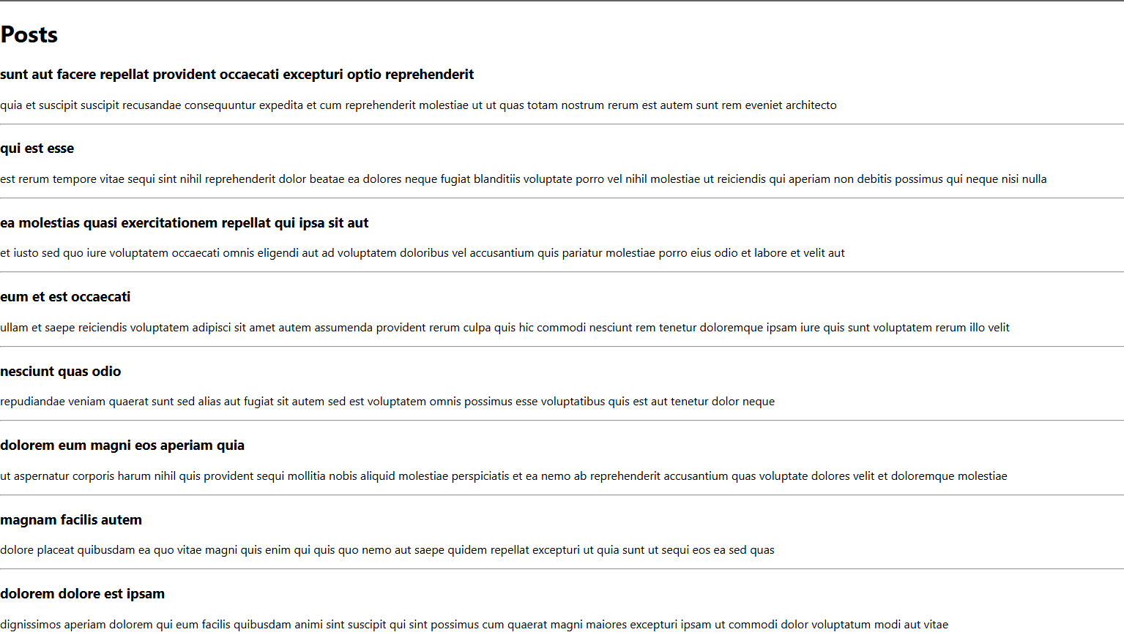

Result
The React application was successfully developed using a class component. The componentDidMount() lifecycle hook was implemented to fetch post data from an external API and display it on the webpage. The componentDidCatch() lifecycle hook was implemented for handling runtime errors. Thus, the React component lifecycle methods were studied and implemented successfully.

